Installing the Citrix Receiver
Citrix Receiver is an app that allows anyone using an Apple, Android, or Windows device to access college software and files remotely. Please follow the instructions below.
Installation
- Download the Receiver at the appropriate location:
  - App Store for iPad/iPhone devices.
  - Google Play for Android devices.
  - http://receiver.citrix.com for Windows or Mac computers (it will auto detect if you are on a Windows or Mac and display the correct option).
- Follow the installation instructions for Windows and Mac computers as shown below:
  - Windows:
    - Click Download Now.
A separate tab will open.
    - Click Download Receiver for Windows.
    - Click the license agreement checkbox, then click Continue.
A file called CitrixReceiverWeb.exe will download to your computer.
    - After the file downloads, open it (if you don't see it immediately, it will be in your Downloads folder on your computer).
The Citrix Receiver Installer opens.
    - Click Install to install the Receiver (this may take a few minutes).
  - Macs:
    - Click Download Now. A separate tab will open.
    - Click Download Receiver for Mac.
    - A file called CitrixReceiverWeb.dmg downloads.
    - Open that file from your Downloads folder.
    - Click the license agreement checkbox, then click Continue.
    - A file called CitrixReceiverWeb.dmg will download to your computer. A Citrix Receiver window will open (if you don't see it, it will be under Devices).
    - Double-click the file Install Citrix Receiver.pkg.
    - The Citrix Receiver Installer opens. Click Continue and follow the install instructions. (This may take a few minutes).
    - When the installation is complete, a message displays.
Starting the Receiver on your Device
- Launch the Receiver on your device:
  - Look for the app icon on the mobile device (iPad/Phone or Android)
  - The start menu on Windows 7.
  - The Applications folder on a Mac.
  - Windows 8/8.1 – go to the Start Screen if you are not already there, type Citrix, and then pin the icon to the Screen or to the Taskbar if you use the Desktop view of Windows 8/8.1.
- All versions will show something very similar to this screen:
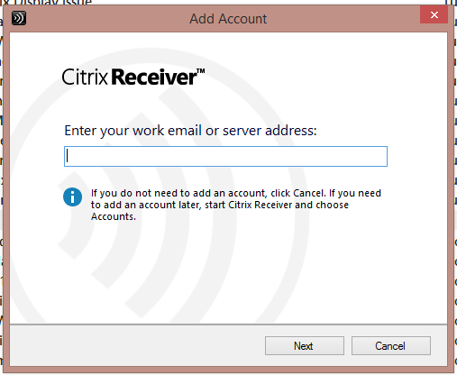
- Enter the appropriate information for the server:
  - Faculty/staff – https://aaccapps.aacc.edu
  - Students – https://studentapps.aacc.edu (depending on your instructor’s information that was provided to you).

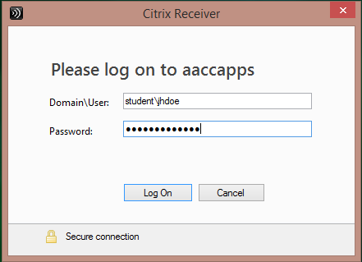

- Enter your user credentials as appropriate, using the following examples:
  - Faculty/staff – aacc\jhdoe
  - Students – student\jhdoe
- Enter your password, the same one you use to login to MyAACC or on a campus computer.
Adding Applications to Receiver

Before you can access any applications you must add them to the Receiver Window.

- The initial screen should look something like this:
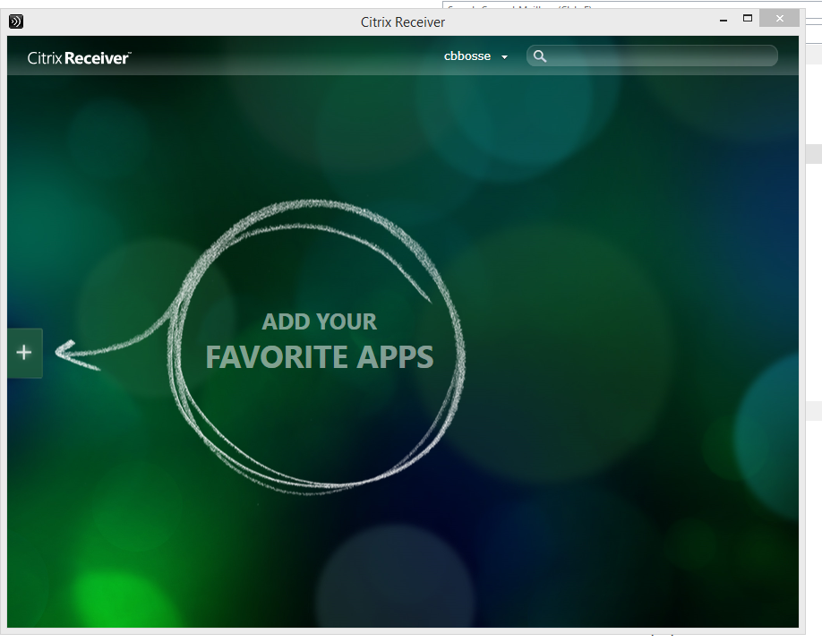
- Click on the big + on the side of the window.
- Click on All Applications (you may see other folders, as this one does, however that depends on the applications that have been assigned to you).
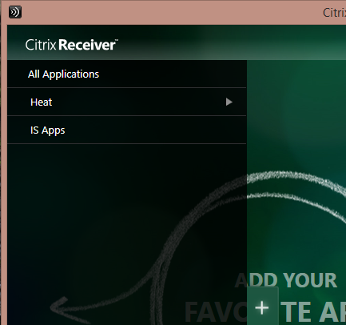

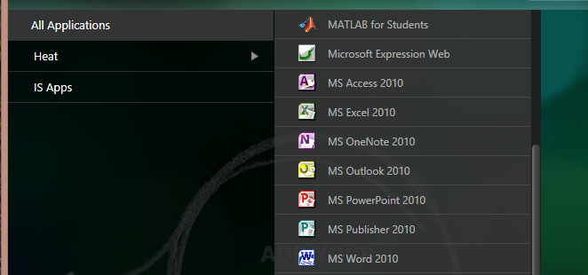
- Select the app or apps you would like to use, they will now show up in the center of the screen.
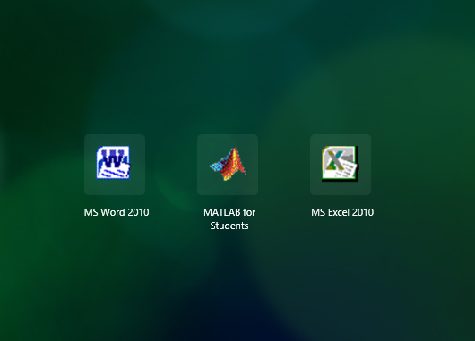
- Launch the app by clicking on it.

Notes:
- The applications you see will vary by what has been assigned to you by the system administrator.
- Periodically you should refresh your apps by clicking by your name and choosing Refresh Apps, that will remove old/inactive icons and update as needed.

