Ready to Take Notes?

**How to Properly (and Actively) Take Notes**:

**Note-taking should not be a passive experience. You should be learning the material as you are reading the multimedia textbook or watching the videos. The notes serve as your foundation before you begin working on a homework assignment. Completing a “You Try It” problem or a practice problem after you have taken notes on an objective (as required in your Note-Taking Guide) will test your understanding and is a crucial element of active note-taking.

**In addition to this document, **more information regarding note-taking procedures and expectations are found at the beginning of the Note-Taking Guide**. Please review both this document and the Note-Taking Guide in detail before beginning your notes.

1. Open your binder to the Notes section. Locate the yellow Note-Taking Guide purchased from the Bookstore, and open to the section you are about to work in.

2. At the top of each page, write your name and the date.

3. Open the textbook to the section you are about to take Notes for by clicking the "Multimedia Library" tab to view

the textbook.

*Note*: There are more detailed instructions about the Textbook and Multimedia Library at the beginning of the Note-Taking Guide. Please review the Guide for more information.

4. You may either read the textbook or watch the videos to learn each objective.

*Note: Read the Note-Taking Guide carefully. Some objectives will require specific examples to be copied from either the textbook or the video.*

a) Textbook - If using the textbook to take Notes, simply keep the textbook open

(You can also use a hard copy textbook to take notes from).

* Actively read and copy Objective 1.
* Actively read through the section for Objective 1.
* At the top of the Note-Taking Guide for that section, write any steps, helpful hints, and definitions found within each Objective section of the textbook.
* In the left column of the Note-Taking Guide, copy at least one example given within the Objective.
* In the right column, complete at least one “You Try It” Problem (found next to certain example problems in the multimedia textbook), a Practice Problem (found under each example problem), or other problem directed by the Note-Taking Guide.

*Note: Read the Note-Taking Guide carefully. Some objectives will require* ***specific*** *practice problems to be completed from either the textbook or the video.*

b) Videos - The videos are found on the first page of each section in the textbook, in the top left corner. There is a video for each objective. **The videos have sound**! If you are watching the videos in class, you will need to use headphones.

* Open the video for Objective 1.
* Actively listen to and copy Objective 1.
* Actively take notes from the Video by placing any definitions, examples, steps, and hints to solve these types of problems at the top of the Note-Taking Guide for that section.
* In the left column of the Note-Taking Guide, copy at least one example from the video given within the Objective.
* In the right column, complete at least one “You Try It” Problem (found next to certain example problems in the multimedia textbook), a Practice Problem (found under each example problem or given in the video), or other problem directed by the Note-Taking Guide.

*Note: Read the note-taking guide carefully. Some objectives will require* ***specific*** *practice problems to be completed from either the textbook or the video.*

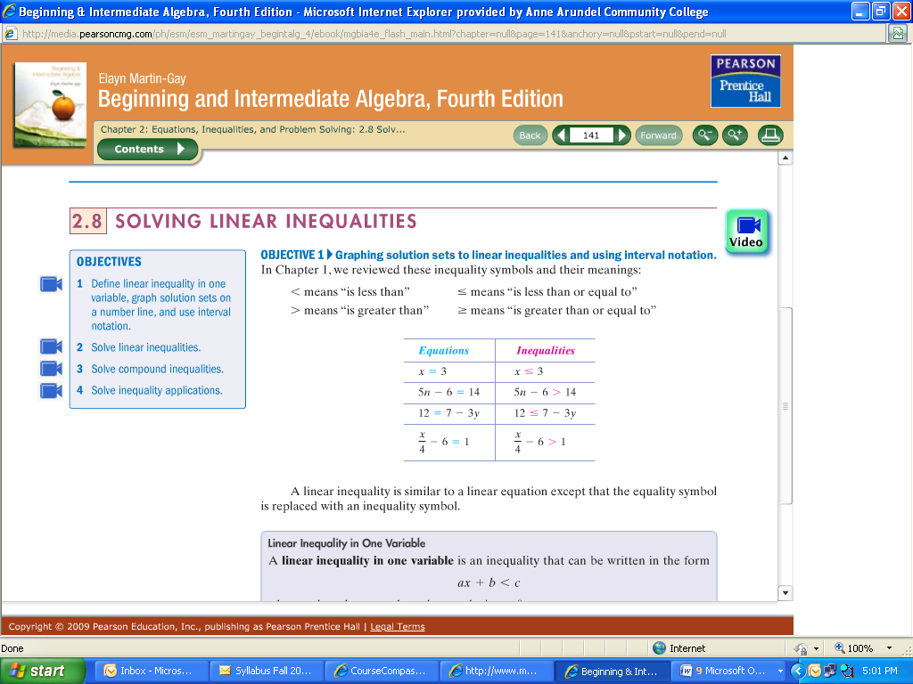

**Videos**

**Textbook**

5. Once finished with Objective 1, follow Step #4 for the remaining Objectives in the section.

*Note: You MUST have Notes for ALL Objectives within each section of your Note-Taking Guide. You can use the textbook, videos, or a combination of both. Remember, the more thorough the Notes you take, the more resources you have to complete your homework as well as to study for quizzes and tests. You may take additional notes, as needed, on loose leaf paper, and place it in sequential order in the Notes section of your binder.*

6. Once you have taken Notes for the *entire* Homework Assignment (there may be 1 *or* 2 sections), you may now start

your Homework Assignment (see “*Ready to Start a Homework Assignment*?”).

** You will **NOT** be able to take any proctored assessment unless your notes are completed. You will be required to show them to either your instructor or the lab manager prior to testing. As a result, you are expected to have your binder and Note-Taking Guide with you each class meeting.