College Algebra Names_____________________________________________
Mini-Project: Group Component

Directions: You must work in small groups of three to four people. Each group will hand in only one completed group component of the project. You must SHOW ALL WORK to receive FULL CREDIT. You must use COMPLETE SENTENCES where appropriate.

Systems of Equations: Application - AUTOMATED HIGHWAY

Automated Highways: New technologies are making automated highways a reality. Experiments are taking place with cars that steer, brake, and accelerate by themselves. Drivers become passengers that can recline, play with the stereo, use their laptop computers, and/or read books. Computers onboard these “driverless cars” pick up signals from magnets that are embedded in the road.

Suppose you are employed by a company that is working with this cutting edge technology. In particular, you are charged with ensuring that the new automated cars will not create traffic jams throughout Anne Arundel County. The figure below shows one of the intersections in the county that you must study to determine the rate of flow of traffic. Each street is a one-way street as the arrows indicate.

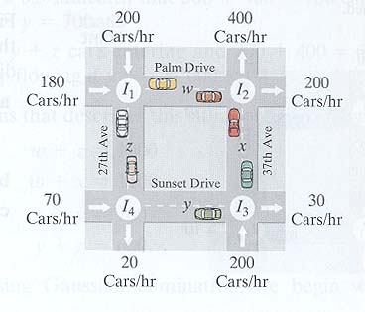
FIGURE

The variables w, x, y, and z represent the number of cars passing between the intersections, which are denoted by I₁, I₂, I₃, and I₄. For example, at intersection three, I₃, there are y+200 cars per hour entering and 30+x cars per hour leaving.
NOTE: There are exactly two arrows entering and two arrows leaving each intersection.

- Determine the number of cars entering each intersection per hour.

  - How many cars are entering I₁ per hour?

  - How many cars are entering I₂ per hour?

  - How many cars are entering I₄ per hour?

- Determine the number of cars leaving each intersection per hour.

  - How many cars are leaving I₁ per hour?

  - How many cars are leaving I₂ per hour?

  - How many cars are leaving I₄ per hour?

- If a traffic jam is to be prevented, the number of cars entering an intersection per hour must equal the number of cars leaving that intersection per hour.

  - Write an equation to prevent a traffic jam at I₁.

  - Write an equation to prevent a traffic jam at I₂.

  - Write an equation to prevent a traffic jam at I₃.

  - Write an equation to prevent a traffic jam at I₄.

- Write each equation above in the form aw + bx +cy + dz = e. (Note: You might have zeros for a, b, c, and/or d for some of your equations if a given variable does not appear in the equation.)

- Write an augmented matrix for this system of equations. Label the matrix A.

- Using your graphing calculator find the Row Reduced Echelon Form (rref) of matrix A and write it in the space provided below. Label this new matrix B.

- What does the last row of matrix B tell you about the type of system you are working with?

- Write the equations that correspond to the first three rows of matrix B.

- Solve each of the three equations above to express w, x, and y in terms of z, i.e. isolate w, x and y in the first, second, and third equations, respectively.

10. Choosing z to be the arbitrary variable, write the solution set for the system as
an ordered triple.

11. Suppose road construction on 27th Avenue between Palm and Sunset Drives
limits traffic flow to 80 cars an hour. Show your work!

- How many cars can pass between I₁ to I₄ per hour?

- How many cars can pass through I₄ to I₃ per hour?

- How many cars can pass through I₃ to I₂ per hour?

- How many cars can pass through I₁ to I₂ per hour?

12. According to your answers from above, which street has the heaviest traffic?
Which street is the least busy?

13. Why would using the inverse matrix method have been a poor choice for this
problem? Explain.

Source: Blitzer, College Algebra, 3rd edition, 2004, Prentice Hall.

