**Group Part**

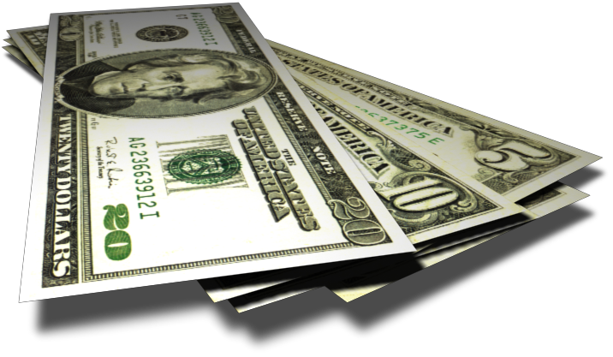

**TO BUY OR NOT TO BUY (CAR)**

**DIRECTIONS:**

* Work in small groups of 2 to 3 people. Feel free to send a representative to another group if your group gets stuck.
* Each group will hand in only **one** completed project at the end of the class period. This version will be graded. Make sure it is an **extra write-up**, not a group member’s original work.
* You must SHOW ALL WORK (including set-ups) to receive full credit. Pay attention to details.
* Don’t forget to include dollar signs.
* **Do not round within an expression, wait until the end of each part.**
* **Round money values to the closest cent.**

1. a) Recently car dealers give incentives to convince people to buy a new car and there may be spectacular deals out there. Let’s say you have been approved by your bank for a car loan up to a certain limit at **7.26% APR** (the compounding monthly is automatically done in the finance formula you are going to use). The car you have selected has a final price tag of **$19,995** (which includes the sales tax and all fees). This is within the margins of what your bank will finance for you. You must make a **down payment of $1000**. The incentive from the dealership is a **$3000 rebate** on the final selling price of the car (prior to any financing). What is the amount you have to pay **monthly** to the bank to have the car loan paid off in **5 years**?

b) While at the car dealership Sam, your enthusiastic new car salesman, offers you another deal worth considering: Don’t take the $3000 rebate, but instead finance the balance (after you make your down payment) through the finance company of the car dealership at **0% APR** with no strings attached. *NOTE: You don’t need a payment formula to figure out how much your monthly payment is going to be since there is no interest involved.* What is the amount you have to pay monthly to the finance company of the car dealership to have the car loan paid off in **5 years**? (Recall: You will have already made a **$1000 down payment**.)

c) Is it the better deal to take the rebate or to take the 0% APR? **Explain**.

1. Sue has borrowed $9,800 from her bank to purchase a used vehicle that has low mileage and is only a few years old. The APR on her loan is 11.5% for 4 years.



1. Determine Sue’s monthly payment.
2. Calculate the total amount that she will have paid back to the bank at the end of the 4 years.

c) Determine the total interest.

1. **Paying back a loan early**: We will use the “Rule of 78s”, which has been widely used by the banking industry for decades, to calculate how much interest cannot be charged by the bank if Sue pays off her loan in a lump sum **in her 30th monthly payment** after having made all preceding monthly payments before. (*Sue has made sure her contract has NO prepayment penalty so that it actually is to her advantage to pay off the loan early*.) Since Sue does not keep her loan the entire 4 years, but the interest was already figured into the monthly payments she is currently making, she is entitled to pay less than what she would have had to if she kept the loan for the entire term.
2. Calculate how much Sue has already paid in her **29** monthly payments she has made so far. (You need to use the payment amount you calculated in # 2(a))
3. Calculate the **unearned interest** according to the “**Rule of 78s**” at the end of the 30th month. (You need to use the interest you calculated in # 2(c) above as well as other information you used in # 2.)

[*Hint: k* = 18]

1. Calculate the **money still owed**, which is the amount that Sue has to send as her 30th payment. (You need to use the payment amount you calculated in #2(a) as well as the unearned interest from # 3(b).)

C:\Documents and Settings\hmriordan\Local Settings\Temporary Internet Files\Content.IE5\P232VPPO\MCj03109940000[1].wmf

1. How much money will Sue now have paid in total?